PRD — Atlas: a knowledge copilot and cadence layer for product teams
Sep 27, 2026 · @Sahil
Atlas makes a product team's operating knowledge — end-to-end flows, integration points, decision checkpoints, ownership and reporting cadence — answerable in natural language and self-maintaining. Any team with a complex flow and a split reporting cadence can run it; ShiMR is the first deployment and the demo case.

Problem
ShiMR decisions across three flow families — onboarding, transaction and funding — at six checkpoint families, and no single place says what each checkpoint does, who owns it, or whether the answer is still current. Client Onboarding, Product Onboarding, CNP and CP Payments Acceptance, Payout, Core Cash and IPDL each derive risk differently, and each has a different partner team on the other side of the API.
That knowledge is spread across a Confluence architecture space, flow walkthrough decks, Gliffy diagrams and the WBR, MBR and Fraud PM monthly documents. Nothing reconciles them. The risk level mapping table alone carries struck-through rows and unresolved <new-request-type TBD> cells beside live ones, so the canonical source visibly disagrees with itself.
Four costs follow:
- Partner teams build on stale assumptions. CPS, MSO, CRS and Credit each integrate against a checkpoint contract they read once. When a rule, a derivation level or a notification path changes, the change is announced in a channel and never lands back in the page they read.
- The same explanation is given repeatedly. Every regional launch, every new partner integration and every new joiner triggers a fresh walkthrough of the same flow by whoever happens to know it.
- Reporting is split across stakeholders with no structure. WBR, MBR and the monthly are assembled from sections owned by different tech and product people. Each contributor needs one section, not a whole document, and nobody can see whose section is late, stale, or contradicts what the WBR said last week. Today the document itself is a shared Word file or deck that travels by email; the coordinator chases each owner by hand, deadlines live in someone’s head, and the final version is stitched together the night before the review.
- Everyone sees everything or nothing. The same flow has to be explained one way to a business stakeholder and another way to an engineer, and some of it — rule content at specific checkpoints — should not be visible to every reader at all. Today the only access control is which deck someone was sent.
None of these is a missing-document problem. The documents exist. The problem is that they are unqueryable, unreconciled, undifferentiated by audience, and maintained by hand.

Users and jobs
Six users. The first four carry the hackathon case because their time is measurable; the last two shape the access model.
User | What they come to do | Today's path
Partner-team PM or engineer (CPS, MSO, CRS, Credit) | Find what Atlas sends at this checkpoint, what it can return, and what changed since they integrated | Finds someone on the team and asks; or reads a page of unknown freshness
WBR, MBR and monthly section owner | Update the one section they own, and see whether it is late or stale, and know when it is due without hunting through email | Hunts for the right slide in a shared deck each cycle
Regional workstream lead (US, CA, APAC, EMEA) | Check which capabilities are live in their region and who owns the gap | Rebuilds the picture from memory and chat history each cycle
New joiner | Walk the flow from account creation to approved, at their own pace | Walkthrough deck plus several weeks of 1:1s
Business stakeholder | Understand what the flow does and where risk is applied, without the systems | Sent an engineering diagram and left to translate it
Admin (product owner) | Decide who sees which layer, and keep rule-level content restricted; for reporting, upload the document, assign sections, set deadlines and download the finished file | No mechanism; access is whichever deck was forwarded; for reporting, emails the file round and merges replies by hand
The section-owner row is the one that changes the build. Because WBR and MBR are assembled from sections owned by different tech and product people, the cadence layer is not one dashboard for one author — it is a per-stakeholder view that shows each contributor only their sections and the state those sections are in.

Solution
Atlas is one knowledge model with a lens-and-access layer on top of it, feeding two surfaces: a chat copilot that answers and walks people through any flow, and a cadence layer that gives each stakeholder only the sections they own. The copilot is a chat panel docked on every screen rather than a separate destination, and the cadence layer runs the whole reporting cycle: upload, assign, notify, collect and export.
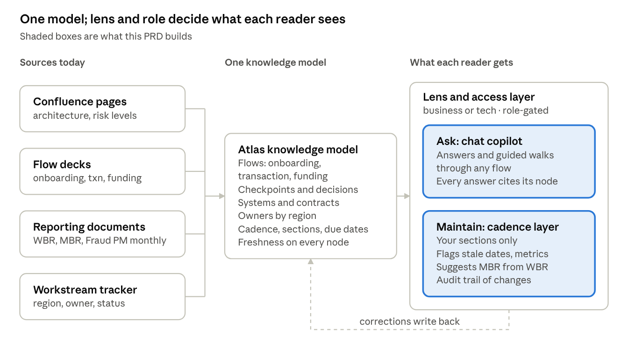
Shield Atlas · four source types, one knowledge model, two surfaces
The two surfaces are the same build, not two projects. The copilot is only trustworthy if the model is current, and the model only stays current because the cadence layer keeps pressure on section owners. Asking is what makes maintaining worth doing.
Chat on every frame. A reader asks about whatever is in front of them — a node on the flow map, a flagged section, a deadline — without leaving it. The panel picks up that context automatically, keeps its thread as the reader moves between tabs, and in Cadence can draft or rewrite the open section for the owner to accept. It never saves or submits on anyone’s behalf.
The lens and access layer sits between them and the model, and it is what makes Atlas portable to other teams. The same node renders differently depending on who is reading:
- Business lens shows what happens and why — the merchant's journey, where a decision is made, what the outcomes are. Systems, APIs and payload contracts are suppressed.
- Tech lens shows the same journey as systems and contracts — which service calls which, what the request and response carry, where the async and callback paths run.
- Role gating decides what exists at all for a given reader. Rule content at specific checkpoints is visible to Risk Strategy and the product owner, and not to a partner team that only needs the contract.
What AI does here that a wiki or a dashboard cannot:
- Reads the existing corpus into structure. Flow decks, Gliffy exports and Confluence pages become checkpoints, systems, contracts and owners without anyone re-authoring them. A wiki needs a human to write the page first.
- Answers a question nobody wrote down. "What does MSO do after a HOLD at product onboarding, and who owns the EMEA gap?" spans a sequence diagram, an architecture page and a workstream table. No page holds that answer; the model can compose it.
- Re-expresses one fact for two audiences. A business lens is not a filtered tech diagram; it is the same fact restated. That is generation, not a view toggle over a table.
- Detects contradiction between sources. Struck-through rows, a status in a deck that disagrees with the tracker, a date that has passed with no update.
- Carries the WBR forward into the MBR. Reading four weeks of section updates and proposing the monthly entry is synthesis across documents, and it is the single feature most likely to get used after the hackathon.

Knowledge model
Eight object types cover everything the copilot needs to answer, the cadence layer needs to watch, and the access layer needs to gate. Each is extracted from material that already exists, so the build spends its days on extraction and reasoning rather than on content authoring.
Object | What it holds | Extracted from
Flow | Onboarding, transaction and funding — the three families a merchant passes through | Flow walkthrough decks
Checkpoint | Client Onboarding, Product Onboarding, CNP and CP Payments Acceptance, Payout, Core Cash, IPDL | Risk level mapping table
Decision path | Approve, Deny, Review or Hold, and what happens downstream of each | Onboarding flow and the product onboarding sequence
System | CPS, SMBDO, WKO, MSO, CRS, Unity, GKS, UPG, Funding Hub, and the platform services themselves | Architecture overview pages
Contract | Decision request and response, callbacks, notifications, manual review request and response | Architecture overview and sequence diagram
Owner | Region, workstream, segment type, current status | Workstream tracker
Cadence section | Which document, which section, which owner, when last updated, when next due | WBR, MBR, Fraud PM monthly
Sensitivity | Which roles may see this node, and under which lens it renders | Set by the admin, not extracted
Every node carries a source pointer and a last-confirmed date. That is what makes an answer auditable and what lets the cadence layer compute staleness rather than guess at it.
Sensitivity is what lets rule content live in the model rather than be excluded from it. Rule-level detail at specific checkpoints is held as restricted nodes: Risk Strategy and the admin see them, a partner team asking about a contract does not, and the copilot says a restricted node exists rather than pretending it does not. That is a better answer than silence, and it is the design decision a judge is most likely to probe.

Reporting cadence
The unit of work is a section, not a document. WBR, MBR and the monthly are each split across tech and product stakeholders, so a contributor signing in sees their own sections and their state — never the whole deck, never someone else's rows.
Four signals drive the view:
Signal | What triggers it | What the owner sees
Stale date | A date in the section has passed with no update, or the section is older than its cadence | The section surfaces with the specific date that expired
Stale metric | A figure has not moved across cycles while the underlying status has, or its source has changed | The figure is flagged with when it was last confirmed
Carry-forward | Four weeks of WBR entries exist and the MBR section is empty | A drafted MBR entry synthesised from those WBR updates, to accept or rewrite
Contradiction | Two sections, or a section and the model, disagree on the same fact | Both statements side by side, with their sources
Every change writes an audit entry: who changed what, when, and what it said before. That is what turns the tool from a drafting aid into something the team can defend a number with, and it is why version history moves into the build rather than sitting in the deferred list.
The admin configures three things: which sections exist and who owns each (now done in Cadence by uploading and assigning, rather than in a config file), which roles see which node types, and which lens a given audience gets by default. Nothing about the access model is hard-coded to one team, which is what makes Atlas portable beyond ShiMR.
Running the cycle, not just watching it. The cadence layer replaces the shared file, not only the status tracker around it. Four capabilities carry that:
- Document intake. The admin uploads the reporting document as it exists today — a Word MBR or monthly, and as a stretch the WBR deck. Atlas scans headings, slides and tables into sections and suggests an owner for each from last cycle and from names already in the document. The admin confirms and assigns; after the first cycle, last cycle’s map is reused.
- Notifications where people already work. Each assignee receives one email or Teams message listing their sections, modelled on the Outlook email Word sends when someone is @mentioned in a comment: who assigned it, which document and section, a two-line excerpt, the due date and one button that opens the section in Atlas. The same assignment appears as a to-do on their Atlas home page and clears itself when they submit.
- A calendar synced with Outlook. The admin sets deadlines and important dates — section due dates, review meetings, change freezes — once, in the Cadence calendar. Atlas writes them into each affected stakeholder’s Outlook calendar and sends reminders ahead of them. Moving a deadline moves every copy and tells the people it affects.
- Download in Word. When every section is in, the admin downloads the compiled document as .docx in the original template, optionally with each owner’s changes as Word tracked changes and open flags as Word comments. The review runs on the same kind of file it always did.
Why a stakeholder would use this instead of Word. The interface has to earn it, because Word is already open on everyone’s machine. The bar is that updating a section in Atlas is faster than finding it in the shared file:
- You see your sections and nothing else — not a forty-slide deck with your two slides somewhere in it.
- There is one live version. No “final_v7”, no merge, no overwritten paragraph.
- Due date, flags and last cycle’s text sit on the section itself, not in an email thread.
- Formatting is the template’s job. Owners write; the compile makes it look right.
- The coordinator never stitches. Compile is one click, and the audit trail says who changed what.
If a screen is slower than doing the same thing in Word, it is a defect, not a design choice.

Scope
Nine days and two people, worked around day jobs. Thirteen capabilities are the committed build, four are stretch, and the rest are named so judges can see the thesis is bigger than the prototype. Flip any row as reality lands. The Sep 27 revision nearly doubles the surface area. Everything it adds sits on the surfaces side and is built against simulated email, Teams and calendar first, so the demo never waits on an access request.
Capability | Scope | Note
Corpus extraction into the knowledge model | In build | Onboarding and transaction flows; funding if time allows
Chat copilot with source citation and freshness | In build | The demo centrepiece
Guided walkthrough of a flow | In build | Chat walks a new joiner stage by stage rather than dumping a diagram
Business and tech lenses | In build | Same node, two renderings; the clearest one-click demo moment
Role-gated visibility, including restricted rule nodes | In build | Two roles are enough to prove it
Per-stakeholder section view with stale date and metric flags | In build | Each contributor sees only their own sections
Audit trail of section changes | In build | Cheap to log, and it is what makes the numbers defensible
Chat panel on every screen | In build | Replaces the Ask tab; context comes from whatever is open
Document upload and sectioning (.docx) | In build | Headings and tables into sections; reuse last cycle’s map
Section assignment with email and Teams notification | In build | Word-comment-style message with one deep link; shown as previews if live send is not approved
Stakeholder home page with to-dos | In build | To-dos clear themselves on submit
Cadence calendar with deadlines and important dates | In build | Atlas calendar plus .ics per person; live Outlook sync is the stretch row below
Compile and download as Word | In build | Original template; tracked changes and comments are a stretch
WBR to MBR carry-forward draft | Stretch | Highest-value feature after the hackathon; needs several cycles of real entries
Contradiction detection across sources | Stretch | Strongest Innovation evidence; protect it if anything above finishes early
.pptx intake and export for the WBR deck | Stretch | The WBR is a deck; .docx proves the flow first
Live email, Teams and two-way Outlook calendar sync | Stretch | Needs Microsoft Graph (mail, calendar) and a Teams bot approved in the sandbox
Admin configuration screen | Deferred | Config lives in a file for the demo, not a UI; section ownership has moved to Cadence (upload and assign)
Write-back into live WBR and MBR documents | Deferred | Write access to live reporting documents is a production concern; the build downloads a compiled .docx instead
Escalation to an owner’s manager | Deferred | Owner reminders are now in build; escalating beyond the owner needs real reporting lines
Protect the demo path above everything: ask a question, switch the lens, hit a restricted node, then upload a document, assign a section, show the notification land as a to-do, and download the Word file. If the build runs late, cut corpus breadth rather than any step in that sequence — a copilot that answers onboarding questions well beats one that answers every flow vaguely.

Success metrics
Headline metric: median time to a correct, sourced answer about a Shield checkpoint, measured by timing five real questions against the current path and against the copilot. It is the number the demo should open and close on.
All baselines are unmeasured today. Capturing them is a week-one task, not a week-two one, because a baseline gathered after the build is not a baseline.
Metric | Why this number | How to get the baseline
Time to a correct, sourced answer | The whole thesis in one number, and cheap to measure honestly | Time yourself and one partner PM answering five fixed questions the current way
Days to first productive question for a new joiner | The ramp cost the org pays on every hire and every transfer | Your own ramp, plus a short ask to the two most recent ShiMR joiners
Hours per cycle per section owner | Recurs every cycle, so time saved compounds | Ask two or three section owners for an honest estimate
Stale or contradictory facts found in the corpus | Proves the problem is real rather than asserted | Count what the extraction pass surfaces, then hand-verify a sample
Answer accuracy on a fixed question set | Without it, every other number is unsupported | Write twenty questions with known answers; score the copilot against them
Coordinator hours to assemble a cycle’s document | The chasing and stitching Word cannot remove, paid every cycle | Ask the WBR and monthly coordinators to time the last cycle
Sections submitted by their due date | Whether notifications, to-dos and the calendar change behaviour | Count on-time replies for the last four cycles from email timestamps
The accuracy row matters more than its weight suggests. An entry claiming a copilot works without a scored question set invites exactly the objection judges are told to raise, and the fix costs an afternoon.

Hackathon fit
Submit to Assistants & Interfaces. The category asks for a natural-language interface on something that today takes expertise or six browser tabs, which is the literal description of the problem, and it is judged on whether a real user can use it unaided — a test that is passable by demoing with a partner-team colleague who has never seen it.
Data & Insight is the runner-up and a reasonable alternative if the extraction work ends up stronger than the interface. Automate the Grind is the wrong home: its bar is autonomy, and the cadence layer drafts for human approval rather than acting alone.
Criterion | Weight | How this entry answers it | Where it is thin
Impact & Value | 30% | Named users, a recurring cost, a headline metric with a real baseline | The baseline has to be captured, not estimated
Innovation & Use of AI | 25% | Contradiction detection across disagreeing sources, and a model that maintains itself | A knowledge assistant is the obvious default here; this is the score to defend
Execution & Working Demo | 20% | Five capabilities working end to end on a real corpus | Extraction quality is the risk; corpus scope has to stay small; the cadence additions widen the surface, so previews stand in for live integrations
Feasibility & Path Forward | 15% | Sources already exist; no new data pipeline; clear owner | Email, Teams and Outlook calendar need Graph permissions the sandbox may not grant; the demo shows previews and .ics, and write-back to live documents stays deferred
Clarity & Storytelling | 10% | One question, asked two ways, is the whole story | Resist explaining the architecture; demo the question
The Innovation row is where this entry wins or loses. "Internal knowledge assistant" is exactly the wrapper-around-an-obvious-default that judges are instructed to mark down. Two things are the defence, and both are in the committed build: the lens switch, because re-expressing one fact for a business and a technical reader is generation rather than a filtered view, and role gating, because a copilot that knows a restricted node exists and declines to use it is a harder problem than retrieval. Contradiction detection is the third and strongest, which is why it is the stretch item worth protecting.

Responsible AI and failure modes
The gate is pass/fail and applied before scoring, and this entry clears every item cleanly.
- Data handling. The sandbox can hold internal documentation, so the corpus sits where it is approved to sit. No customer data, PII or transaction records enter the model at any point. Atlas reads documentation only. Notifications carry section titles, due dates and a short excerpt of the recipient’s own section — never restricted content or anyone else’s section — and go only to people in the firm directory.
- Approved tooling. The internal Copilot connected to Bitbucket is approved. Design and specification happen outside, the build itself runs in the approved environment, and no internal content is routed to an unapproved service.
- Failure disclosure. Named below, with who each would harm.
- Human oversight. Structural rather than bolted on: Atlas makes no decision about any person or account, and the decisioning path is untouched. Cadence drafts are proposals an owner approves before anything lands. Atlas never assigns, sends, moves a deadline or exports without an admin action.
- AI disclosure. Declare that the build was produced with AI assistance, including any part of the write-up. Undisclosed fabrication is the one unrecoverable offence in the rules.
One thing the sandbox does not solve: the demo recording leaves the sandbox. Record against a redacted corpus — real merchant names, volumes and live rule content out, flow structure and system names in — because a recording of live internal pages becomes a confidential artifact the moment it is submitted.
Failure modes, in the order they would actually bite:
- Restricted content leaks through the copilot. A partner-team reader asks a contract question and the answer composes from a restricted rule node. This is the most severe mode and the one the access model creates, so gate at retrieval rather than at rendering: a restricted node must never enter the context that generates the answer. Harms Risk Strategy and the control posture around rule content.
- A confident wrong answer about a checkpoint contract. A partner team integrates against it and the defect surfaces late. Harms partner engineering and, downstream, merchants whose onboarding breaks. Mitigation: every answer cites its source node, so verification is one click.
- A stale fact not flagged as stale. Worse than no tool, because a freshness date creates trust it has not earned. Mitigation: unverifiable nodes display as unknown rather than current, and the demo should show this case.
- Superseded content read as live. The risk level mapping table alone carries struck-through rows beside active ones. Mitigation: treat struck-through and TBD content as a contradiction signal, not as content.
- A laundered number in a leadership document. A carry-forward draft carries a figure nobody verified into an MBR. Harms whoever presents it. Mitigation: drafts carry their source or carry a visible gap, never a plausible number.
- A notification exposes content to the wrong person. A mis-assigned section sends its excerpt to someone who should not see it. Mitigation: excerpts come only from the section itself, assignment is confirmed before sending, and recipients are limited to the directory. Harms whoever owns the content.
- Sectioning drops or misplaces content. A table or slide falls between sections and never gets updated. Mitigation: anything outside a section shows as unassigned and blocks export. Harms the coordinator presenting the document.
- Notification fatigue. Too many messages and people filter them out, which is worse than none. Mitigation: one message per person per document, reminders stop on submit, one nudge per day at most. Harms adoption.

Build plan
Submission is Oct 6, which leaves seven working days and one weekend from tomorrow. Two people, worked around day jobs.
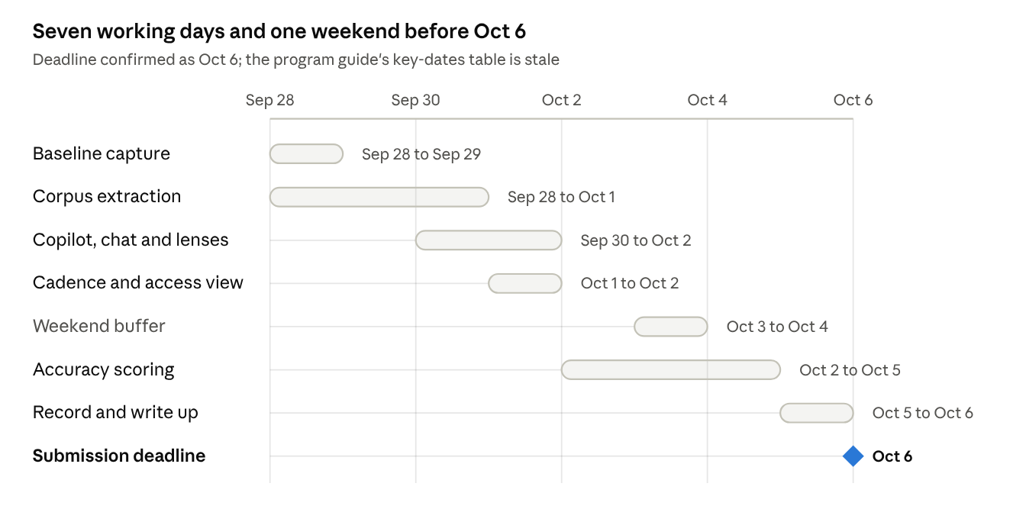
Build plan · nine spans and milestones, Sept 28 to Oct 16
How the work splits across two people matters more than the dates. One owns extraction and the knowledge model, the other owns the surfaces — chat, lenses, cadence view. They meet at a fixed model schema agreed on day one, which is the only hard dependency between them and the thing to settle before either starts coding. The Sep 27 additions — chat panel, upload and sectioning, assignment and notifications, home to-dos, calendar and Word export — all land on the surfaces owner. The extraction owner’s one new job is the document scanner, which reuses the heading and table parsing already needed for the corpus.
The toolchain is a two-step: design and specify outside, then build inside the approved environment with Copilot and Bitbucket. Keep the model schema and the corpus map as files that move cleanly between the two, and avoid any design that needs a round trip mid-build.
Three sequencing choices matter:
- Baseline in the first two days. Once the tool exists, nobody remembers how long the old way took, and Impact is 30% of the score.
- Accuracy scoring starts Oct 2, not Oct 5. Writing the question set early also forces the extraction to be good enough, and leaves Monday for scoring rather than authoring.
- Treat the weekend as buffer, not capacity. The program assumes no weekend work. If the plan only closes by using Oct 3 and 4, it does not close.
The critical path is extraction. If it is going badly by Oct 1, cut to the onboarding flow alone and put the saved time into the lens switch and the cadence view, because those are what the demo turns on.

Open questions
The first two need answering tomorrow.
- ☐ Agree the knowledge model schema between the two of you on day one. It is the only hard dependency between the extraction half and the surfaces half, and getting it wrong on Oct 1 costs days there are not.
- ☐ Get the section-to-owner map for WBR, MBR and the monthly. It is input data, not something extraction can infer, and the cadence view cannot be demoed without it.
- ☐ Which second flow after onboarding — transaction or funding? Pick the one with the cleaner existing documentation, not the more interesting one.
- ☐ Which two roles to demo the gating with? Suggest a partner-team reader and Risk Strategy, since the contrast on rule nodes is the sharpest.
- ☐ Ask two or three section owners for an honest hours-per-cycle estimate this week. That one conversation carries the Impact score.
- ☐ Find a colleague outside the team to test the copilot unaided before Oct 5. The category is judged on it.
- ☐ Is "Atlas" free as a name internally? It is a placeholder chosen to be team-agnostic, not a commitment.
- ☐ Does the sandbox allow Microsoft Graph (Mail.Send, Calendars.ReadWrite) and a Teams bot? If not, the demo shows in-product previews and .ics downloads — decide by Sep 30.
- ☐ Which document is the upload demo? The Fraud Monthly Roadmap is .docx and the natural first; the WBR is a .pptx deck and is the stretch.
- ☐ Who is the coordinator (admin) for each document — one person for all three, or one per document?
Screens, tabs, filters, icons and work-flow requirements: Functional requirements

